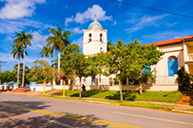 Cuba
Program offerings include:
- The Cuban Revolution and how it has impacted families and the country
- The effect of the decades-old blockade on the country
- The high priority given to healthcare and education for all
- Recent efforts at organic food production
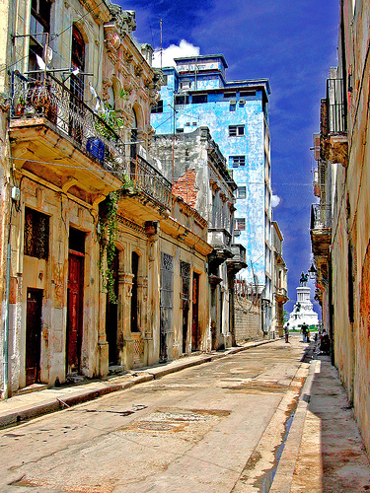
- The value given to the arts in people’s lives
Other programmed activities include
- A guided tour of the Bay of Pigs Museum
- A visit to the highly specialized neurological center
- An ecological preserve
- A late-afternoon visit to the former DuPont home
- An opportunity to interact with children at a school
- A presentation on current Cuban family life
- A presentation on the Cuban system of government
- Time at a Cuban art museum
- Time in Old Havana and handicraft and art markets
- Family-owned restaurants
- A music or dance performance
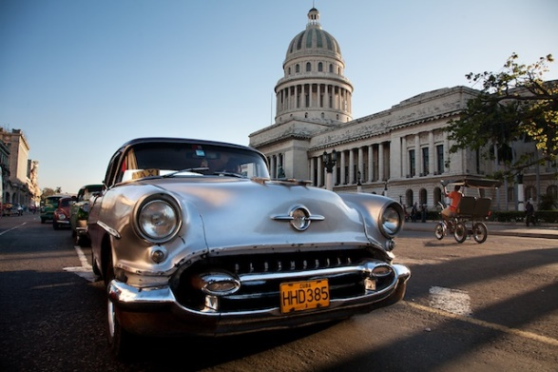
- And more!

See www.GATE-Travel.org for registration and program costs.
Phone: 608-791-5283 • Email: gate@fspa.org

